Advanced PCIe 4.0 NVMe performance

[Watch Video](https://www.kingston.com/en/video/play?videoId=AOk-ntKdoXm3B55L_RMZgUpUbGbqjCBPtvDylfOzlZiG1d5sXEFc1Io_UYFpwU_7g-eMl5Zt7fZNef3lOg4Z6g2&start=0&autoPlay=False&chromeless=False&captionOption=No)

KC3000

* [Intro](https://www.kingston.com/en/ssd/kc3000-nvme-m2-solid-state-drive#product-features)
* [Key Features](https://www.kingston.com/en/ssd/kc3000-nvme-m2-solid-state-drive#key-feature)
* [Specifications](https://www.kingston.com/en/ssd/kc3000-nvme-m2-solid-state-drive#specifications)
* [Resources](https://www.kingston.com/en/ssd/kc3000-nvme-m2-solid-state-drive#links)
* [Datasheet](https://www.kingston.com/datasheets/KC3000_us.pdf)

[**Buy**](https://www.kingston.com/en/ssd/kc3000-nvme-m2-solid-state-drive#atc)

KC3000 PCIe 4.0 NVMe M.2 SSDHigh-Performance Storage for Desktop and Laptop PCs

Kingston KC3000 PCIe 4.0 NVMe M.2 SSD delivers next-level performance using the latest Gen 4x4 NVMe controller and 3D TLC NAND. Upgrade the storage and reliability of your system to keep up with demanding workloads and experience better performance with software applications such as 3D rendering and 4K+ content creation. With formidable speeds up to 7,000MB/s1 read/write, it ensures improved workflow in high-performance desktop and laptop PCs making it ideal for power users who require the fastest speeds on the market.

The compact M.2 2280 design fits seamlessly into motherboards and gives greater flexibility where high-power users appreciate responsiveness and superior loading times.

Full capacities available from 512GB–4096GB2 to meet your data storage requirements.

* PCIe 4.0 NVMe high-performance
* Upgrade with full capacities up to 4096GB2
* Compact M.2 2280 form factor
* Low profile graphene aluminum heat spreader

Key Features



PCIe 4.0 NVMe Technology

Master intensive applications with speeds up to 7,000/7,000MB/s1 read/write.



Store more

Upgrade and manage storage with full capacities up to 4096GB2.

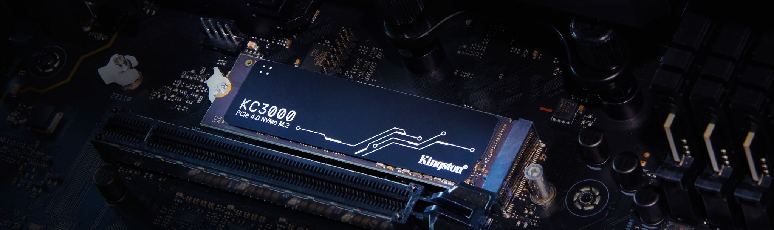

Greater flexibility

Compact M.2 design fits easily into small form factor (SFF) systems, desktops and laptop PCs.

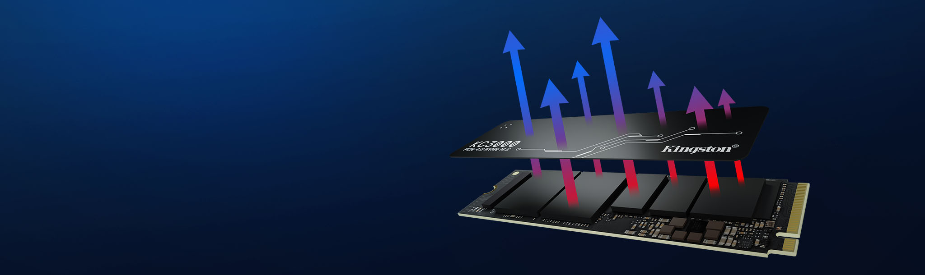

Low profile graphene aluminum heat spreader

Exceptional thermal dissipation keeps your drive cool with maximum performance.



**Ask an SSD Expert**

Planning the right solution requires an understanding of your project's security goals. Let Kingston's experts guide you.

[**Ask an Expert**](https://www.kingston.com/en/ssd/desktop-laptop-workstations/ask-an-expert)

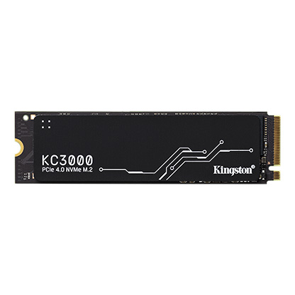

* [KC3000 PCIe 4.0 NVMe M.2 SSD - 512 GB](javascript:void(0))
* [KC3000 PCIe 4.0 NVMe M.2 SSD - 512 GB](javascript:void(0))
* [KC3000 PCIe 4.0 NVMe M.2 SSD - 512 GB](javascript:void(0))

Capacity

 512GB

 1024GB

 2048GB

 4096GB

* Part Number: SKC3000S/512G
* PCIe 4.0 NVMe M.2
* 7,000MB/s Read, 3,900MB/s Write
* Includes [Acronis cloning software](https://www.kingston.com/cloning)
* Single-sided

[**Where to Buy**](https://www.kingston.com/en/wheretobuy)